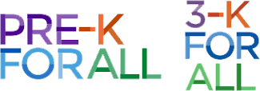
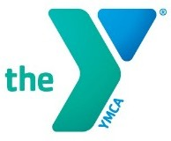
Flushing YMCA PRE-K/ 3-K FOR ALL

2026-2027 School Calendar

DATE | WEEKDAY | EVENT
September 10 | Thursday | First Day of School
October 7 | Wednesday | Curriculum Night
October 12 | Monday | Indigenous People’s Day & Professional Day (schools closed)
November 3 | Tuesday | Election Day / Professional Learning Day (schools closed)
November 11 | Wednesday | Professional Learning Day (schools closed)
November 26-27 | Thursday - Friday | Thanksgiving Recess, schools closed
December 7-11 | Monday – Friday | Parent-Teacher Conferences  (Wednesday 12/9 early dismissal at 12:30 p.m.)
December 24-January 1 | Thursday -Friday | Winter Recess, schools closed
January 18 | Monday | Rev. Dr. Martin Luther King Jr. Day, schools closed
February 1 | Monday | Professional Learning Day (schools closed)
February 15-19 | Monday - Friday | Midwinter Recess, schools closed (includes Presidents Day and Lincoln’s Birthday (observed)
April 22-30 | Thursday - Friday | Spring Recess, schools closed
May 5 | Wednesday | Professional Learning Day, schools closed
May 10-14 | Monday - Friday | Parent-Teacher Conferences  (Wednesday 5/12 early dismissal at 12:30 p.m.)
May 31 | Monday | Memorial Day, schools closed
June 10 | Thursday | Professional Learning Day, schools closed
June 18 | Friday | Juneteenth, schools closed (TBD)
June 24 | Thursday | Last Day of School

- Please note that these dates may be subject to change*
- As prescribed by the DOE there will be 176 days of school*

